**Computational Guided Inquiry: Investigating Sea Level Rise Impacts in Tacoma, WA**

**Learning Objectives**

1. Increase climate literacy by connecting sea level rise due to ice melt in the Polar Regions to local impacts in Tacoma, WA.
2. Learn tools to apply to decision-making given uncertainty in sea level rise and flooding.
3. Gain computational skills through calculating and graphing marginal expected damage curves in Excel.

**Pre-class activities**

1. Read the Introduction below, which includes the linked article: [How is World Sea Level Rise Driven by Melting Arctic Ice?](https://www.scientificamerican.com/article/how-is-worldwide-sea-level-rise-driven-by-melting-arctic-ice/) (Sneed, A. 2017) and a short [video](http://video.nationalgeographic.com/video/magazine/170622-ngm-antarctica-melting-sea-levels-climate-change), then answer the Pause for Analysis questions.

2. Explore the Riskfinder.org website for Tacoma, WA and answer the Discussion Questions.

**Introduction**

*Polar Connection*

One of the biggest expected impacts of climate change will be the rise in sea levels around the world as temperature increases and ice in the Polar regions continues to melt at an accelerated pace. Current studies estimate that the total increase in sea level by 2100 will range from 0.2 to 2 meters (NOAA 2016), but there is also the possibility of an increase of 3 meters or more depending on how fast ice in the Arctic and Antarctic regions melts.

Sea level rise (SLR) will have significant consequences for coastal cities around the U.S. where an increase of 0.9 meters would displace 2 million or more Americans (Hauer et al. 2016). Higher seas also result in higher flood levels and storm surges, which along with increased extreme weather events, will potentially cost billions of dollars in damages. Hurricane Sandy, which hit the Eastern Coast of the U.S. in 2012 and flooded New York’s subway system is reported to have cost $50 billion in damages (Murphy 2015).

While changes in sea levels are expected to be relatively gradual, taking place over hundreds of years, there is much uncertainty in the timing and extent of future SLR. Cities need to start preparing for the coming SLR now, however, trying to determine the best course of action from a policy and urban planning perspective is challenging.

To get a better idea about how Polar regions can affect global sea level rise, start by reading this article from the Scientific American: [How is World Sea Level Rise Driven by Melting Arctic Ice?](https://www.scientificamerican.com/article/how-is-worldwide-sea-level-rise-driven-by-melting-arctic-ice/)[1]

In addition to contributions to sea level rise from the Greenland Ice Sheet in the northern hemisphere, Antarctica in the southern hemisphere is also predicted to contribute to future increases.

A recent paper in *Nature* by DeConto and Pollard (2016) modeled extreme scenarios of ice melt in Antarctica and found that it could contribute as much as an additional meter to SLR by 2100 and more than 15 meters by 2500.

To learn more about the contribution of Antarctic ice melt to sea level rise, watch this short [video](http://video.nationalgeographic.com/video/magazine/170622-ngm-antarctica-melting-sea-levels-climate-change) (3:40) from National Geographic.[2]

**Figure 1. Large Ensemble mod analyses of future Antarctic contributions to GMSL**

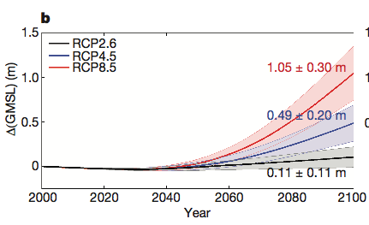

The graph above is from the DeConto and Pollard (2016) paper and shows Antarctic’s potential contribution to global mean sea level rise (GMSL) in meters by the year 2100.

**Pause for Analysis**

a. What is the key difference between land ice and sea ice in terms of how their melting will impact sea level rise?

b. If you had to guess, what do you think is driving the different trajectories of SLR (e.g. RCP2.6, RCP4.5, etc.) over time?

***Sea Level Rise Impacts in Tacoma, WA***

Now take a couple minutes to explore the [Risk Finder website](https://riskfinder.climatecentral.org/place/tacoma.wa.us?comparisonType=city-council-district&forecastType=NRC_High&level=4&unit=ft)[3] that looks at the impacts of flooding in Tacoma under different sea level rise scenarios.

Answer the following questions based on information from the website.

a. How many different sea level rise scenarios are there? List them below.

b. How many people in the Tacoma population are at risk given 6ft of flooding? (Hint: adjust the water level meter on the left.)

c. How many homes are at risk given 8ft of flooding? (Hint: click on the ‘Buildings’ tab under ‘What Is at Risk?’)

**Discussion Questions**

1. What factors do you think need to be taken into consideration when deciding how much money a city should spend on adaptation and protection against sea level rise?

2. What do you think are some of the biggest challenges regional planners face when making these decisions?

In the following sections you will learn some decision-making tools that incorporate risk and uncertainty into estimating the damage costs of sea level rise and flooding in Tacoma. To conduct this analysis you will gather data on property values and flood probabilities and apply them to a decision-making framework using economic models.

**Part I. Calculating Marginal Damages from Flooding**

**Open your Excel spreadsheet and look at Table 1 on the ‘MD Table’ tab to see the total number of homes that will be exposed at each level of flooding in Tacoma.**

With higher sea levels come more frequent and higher flood events. One way to estimate the impact of SLR due to ice melt in the Polar Regions is to look at the associated damages from higher flood levels. To start, we need to get an estimate of the total property damage that would occur at each level of flooding. To do this, we need an estimate of housing values in Tacoma that are most exposed to floods.

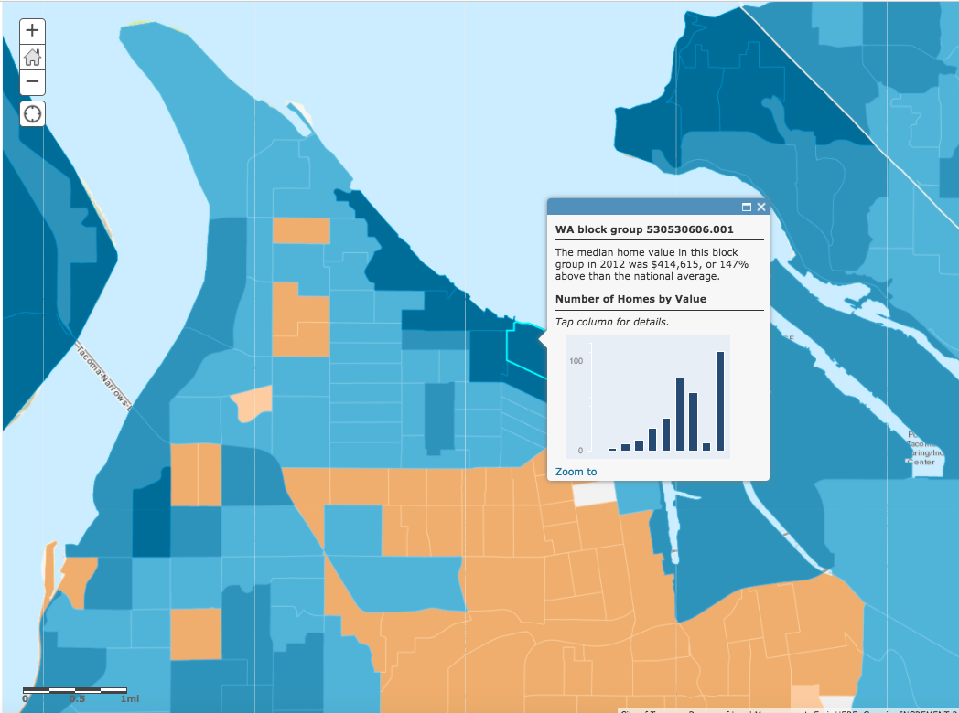

This [link](https://www.arcgis.com/home/webmap/viewer.html?layers=8abd47c2988d497a8f24ad89180980c8) will take you to a map with median home values in the U.S. from 2012 by block group. **[4]**

**Click the link and zoom in on the map to Tacoma using the ‘+’ button in the upper left corner.**

**Click on a block to see the median home price in that block group for 2012.**

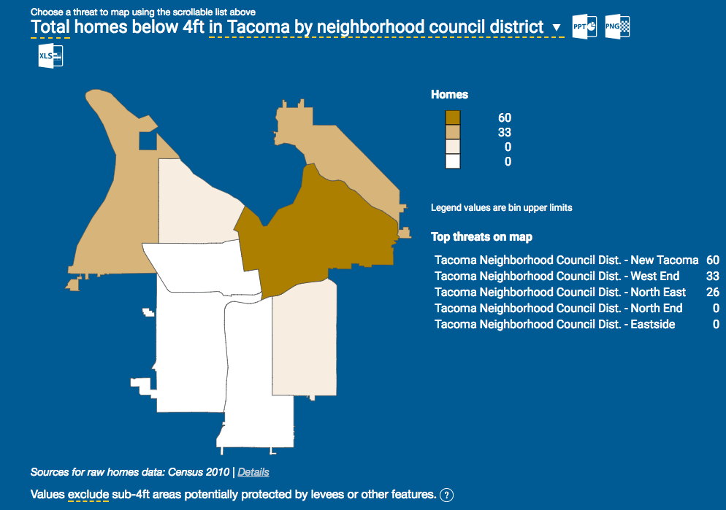**Now look at the** [**Risk Finder website**](http://riskfinder.climatecentral.org/place/tacoma.wa.us?comparisonType=neighborhood-council-district&forecastType=NOAA2017_inthi_p50&impact=Housing&impactGroup=Buildings&level=4&unit=ft)**[5] for Tacoma and scroll down to see what areas of Tacoma are most at risk due to flooding.**

**Compare these two maps and decide on a median home price to use for the analysis.**

**BACK TO EXCEL**

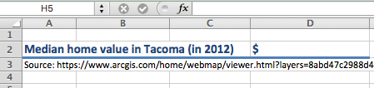**Once you have a price, double click on cell D2. Type the value into your Excel spreadsheet and hit ‘enter’.**

After you type in your median home value in Excel, Columns C and D should populate with the total property damages at each flood level, which is calculated by multiplying the number of houses exposed (Column B) by the median home value you just selected to get the total damages (Column C). Note column D is the total damages in millions.

**Pause for Analysis**

|  |
| --- |
| 1. Justify why you chose to use that home price for this analysis (i.e. what considerations did you make when choosing a median home value?). |
|  |

Now that we have estimates of damage costs, we have to figure out how to use this information. To determine how much an urban center should spend on flood protection, planners need to consider the *marginal* damages done by additional flooding. The **marginal damage of flooding** is the loss in property value that is associated with an additional foot of flooding, or

In your Excel spreadsheet, we can calculate the marginal damage from the first foot of flooding by subtracting the change in total damages from 1 to 0 feet of flooding (numerator) over the change in feet of flooding (denominator). Note that changes in flood levels are in 1 foot increments, so the denominator will be “1” for all calculations.

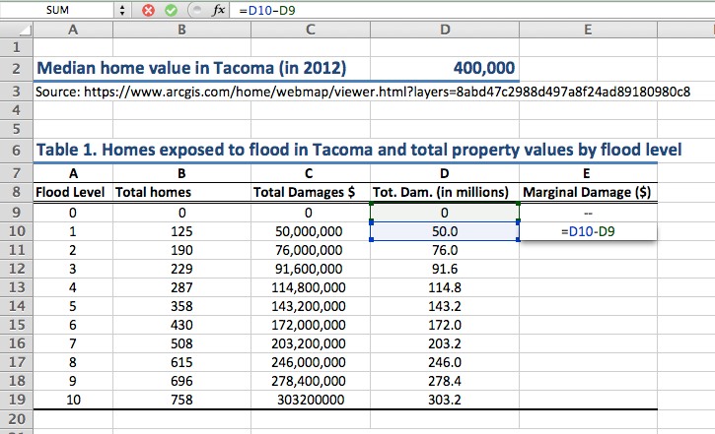

**To subtract the total damages given 1ft of flooding from damages with 0ft of flooding, type the formula ‘=D10-D9’ into cell E10, under the Marginal Damages column then hit ‘enter’.**

Note: you can also *click* on the cell to fill in the cell reference (e.g. D10) instead of typing it.

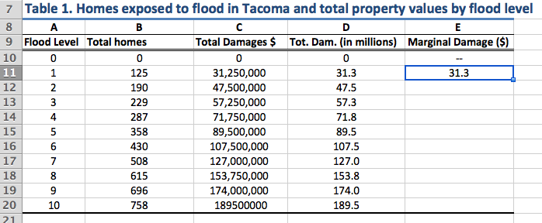

**Next, click on the cell to show the blue border, then click on the square in the lower right corner and drag it down to the last cell in the column to copy the formula into these cells.**

**Pause for Understanding**

|  |
| --- |
| In one sentence, explain what the value in cell (E16) in Table 1 represents. Be as specific as possible. |
|  |

**Part II. Calculating Expected Damages of Flooding**

With climate change comes a lot of risk and uncertainty, both in how much sea levels will rise as well as the maximum flood levels associated with each SLR scenario. One way to incorporate this risk into decision-making is by estimating the **expected value of damages** given the probability that floods will reach a certain height.

For each maximum flood height, there are two possible outcomes: the flood reaches *i* height (for example *i*= 4ft), or the flood does not. Thus there are two probabilities: *pF,4* is the probability of a maximum Flood of 4ft, and *pNF,4* is the probability of No Flood of 4ft.

To calculate the expected marginal damages associated with a 4ft flood, we multiply the probability of the flood, *pF,4*, by the marginal damages that would occur at that flood height, *xF,4*, plus the probability of no flooding at 4ft, *pNF,4*, by the marginal damages, *xNF,4* , which would be zero since there is no flooding. The general formula for each flood level *i*, is:

Next, we will use this formula to calculate the expected marginal damage (MD) for each flood level for the four different Sea Level Rise scenarios: slow, medium, high, and extreme. Note that since the marginal damages of no flood occurring will always be zero, the second term in the equation drops out, and we only have to calculate *pF,i * xF,i .*

**BACK TO EXCEL**

In **Table 2A**, I have calculated the expected MD for each flood level by SLR scenario for the year 2050. (Note that the marginal damages in column B are the same as the ones you calculated above.)

**Now *you* calculate the expected MD for Table 2B for the Medium SLR scenario. To do this, multiply the marginal damage of flooding (*xF,1* ) by the probability of flooding (*pF,1* ) for a max flood height of 1ft using the formula ‘=B40*E40’ in Excel.**

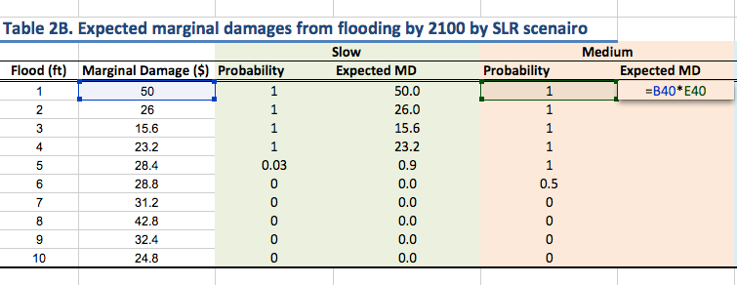

**Then drag down the formula to replicate it in the rest of the column.**

Tables 2A and 2B are now complete. To fill out the rest of Table 2C you will need to get data on the probabilities of flooding at each water level for the year 2150 from the Riskfinder.org website.

**Go to the Risk Finder Tacoma** [**website**](https://riskfinder.climatecentral.org/place/tacoma.wa.us?comparisonType=city-council-district&forecastType=NOAA2017_int_p50&level=4&unit=ft) **and select the ‘Slow rise’ *Sea level scenario* on the right side of the graph and then the 4ft *Water level* on the left side. Hover over the year of interest on the bar chart (2150).**

You see that the probability of a flood of 4ft or more by 2150 is 100% (or 1.0)

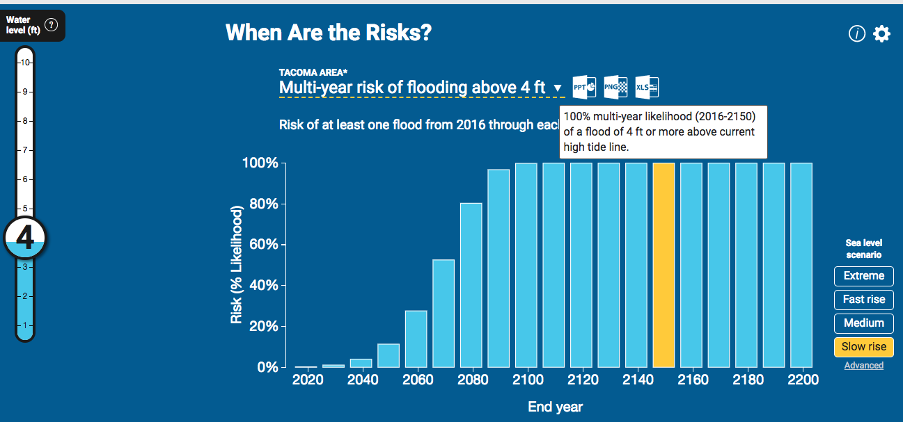

**Do this for each water level to fill in the probabilities in Table 2C for the Slow and Extreme scenarios.**

**Then calculate the expected MDs as you did above in Table 2B.**

**Pause for Understanding**

|  |
| --- |
| In 1-2 sentences, explain what the value in the yellow highlighted cell (D28) in Table 2A represents. Be as specific as possible. |
|  |

**Part III. Graphing Marginal Damage Curves**

The tables are a helpful way to organize the data and do some basic calculations, but when presenting the data, graphs are a better way to convey a lot of information in one figure. In this section we will make graphs of the expected marginal damage curves you just calculated for each SLR scenario.

**IN EXCEL**

**At the bottom of the Excel window click on the ‘MD graphs’ tab.** Here you will see 3 tables, each showing the different SLR scenarios and expected flood damages for years, 2050, 2100, and 2150. The tables have automatically populated with the expected MD values you calculated on the previous spreadsheet.

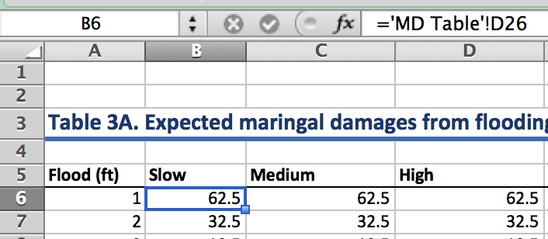

Note: If you click on a cell, you can see the reference cell it’s drawing the data from in the formula bar (*fx*) at the top, where ‘MD Table’ is the sheet name you were previously working in and D26 is the cell on that sheet the data is copied from.

I have already made a graph of Table 3A, now you will make a graph of Table 3B.

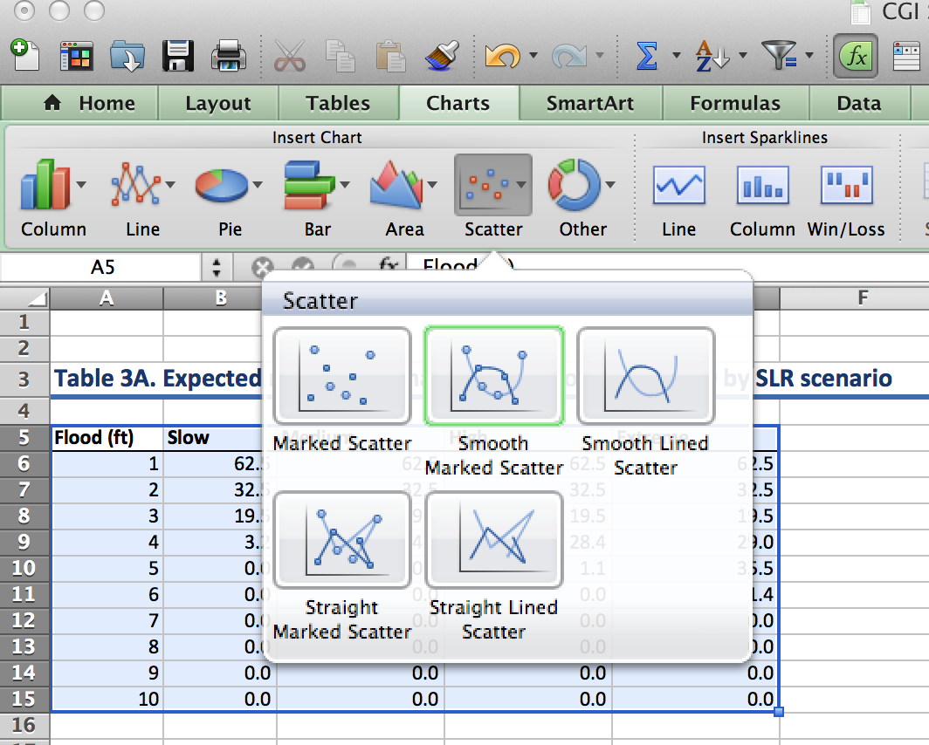

**To make a graph in Excel:**

**1. Use the cursor and drag to highlight the contents of Table 3B as pictured.**

**2. Click Insert > Chart > Scatter > Smooth Marked Scatter**

**Then a graph should appear in the spreadsheet!**

You can click on the graph to move it around on your spreadsheet.

Note: The x-axis will be based on the left-hand column units (feet) and the y-axis will be the units from the columns to the right (millions of dollars). The legend is based on the column headings.

**Next, repeat the same thing to make a graph of Table 3C.**

Once your graphs are created, you will want to add titles to the graph and the axes. If someone was to look at your graph out of context, they should be able to understand exactly what data is being displayed.

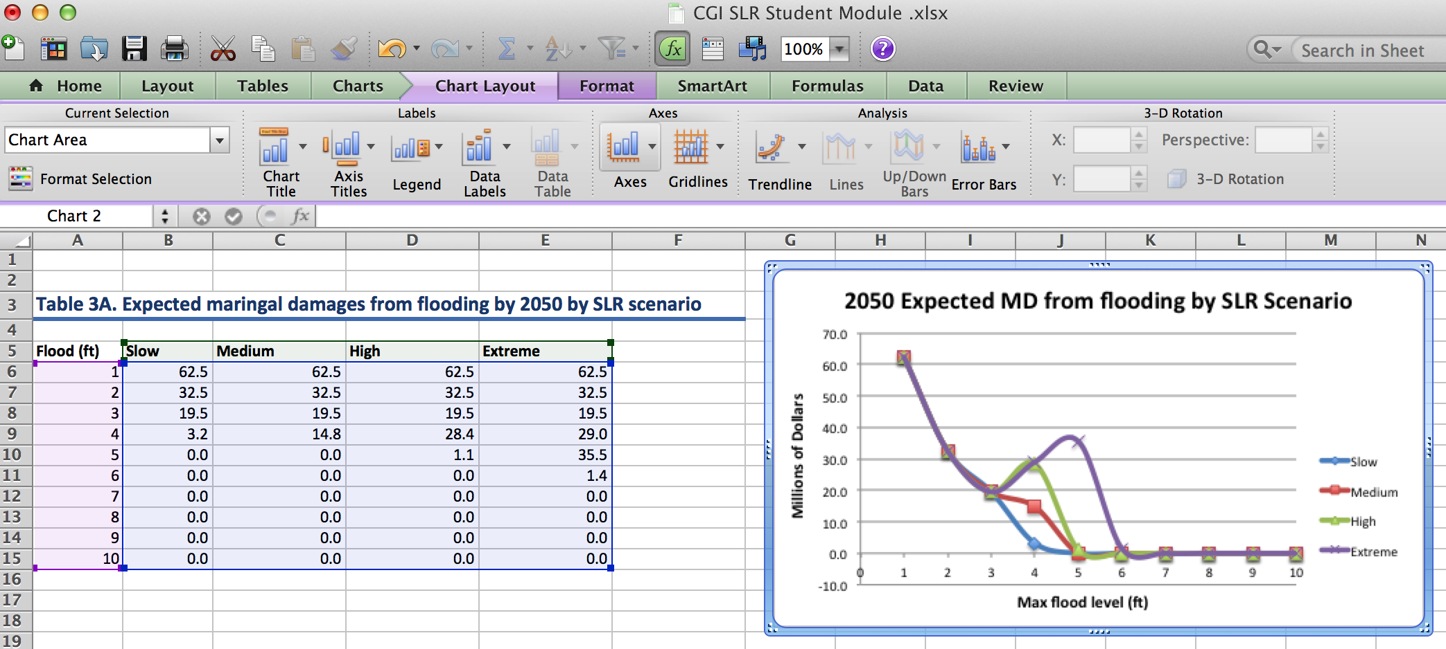

**To add titles, click anywhere on the graph and then you should see a ‘Chart Layout’ tab appear. Click on that and from there you should see options for adding a Chart Title and Axis Titles.**

**Pause for Analysis**

|  |
| --- |
| 2. Looking at the graphs, what is your hypothesis for why the highest marginal damages are from the first couple feet of flooding? |
|  |
| 3. Comparing the three graphs, what is a claim you can make about damages from sea level rise? Support your claim with evidence from the graphs. |
|  |

**Pause for Reflection**

You now have three graphs to analyze that show expected marginal damages from flooding over different time periods. While they provide useful information, as a policy-maker in Tacoma, what challenges and limitations do you foresee in using these graphs for decision making?

|  |
| --- |
| **Briefly Explain:** |

**Part IV. Making decisions given uncertainty**

Along with risk and uncertainty about the likelihood of maximum flood levels, there is also inherent uncertainty about which sea level rise scenario is most likely to play out. One way to account for this uncertainty in decision-making is by using the same expected value approach we used for calculating the expected marginal damages of flooding.

There are four SLR scenarios that will occur with some probability, *pj*, where *j* represents the SLR scenario: slow, medium, high, or extreme. For each flood level, *i*, we can estimate the expected marginal damage given the probability of each SLR scenario.

|  |  |  |
| --- | --- | --- |
| Determining the probability of each SLR scenario occurring given Polar ice melt is a current area of research by climate scientists. To prepare for the next Excel activity, think about the different scenarios and assign probabilities to each one below. It’s okay if this is arbitrary. | | |
| **Scenario** | **Probability** | Remember that the scenarios are mutually exclusive, so the probabilities must sum to one. |
| Slow (0.2 meter rise) |  |
| Medium (1.0 meter rise) |  |
| High (2.0 meter rise) |  |
| Extreme (3 meter rise) |  |

**BACK TO EXCEL**

We can use the probabilities you just assigned for the SLR scenarios to graph one expected marginal damage curve that incorporates the likelihood of each scenario occurring.

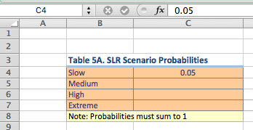**Click on the ‘MD MC Graph’ tab at the bottom of your Excel worksheet.**

At the top you will see a Table 5A for SLR scenarios probabilities.

**Type in your probabilities from above for each SLR scenario.**

Notice, after you fill in the probabilities, Table 5B automatically populates using the marginal expected damage formula for the year 2100. To the right you can see the graph of the expected marginal damage curve based on the probabilities you chose.

The likelihood of different SLR scenarios occurring will directly impact the expected marginal damages associated with SLR and flooding. To better understand this idea, we can adjust the probabilities of different scenarios occurring and compare the marginal damage curves.

**In Table 6A 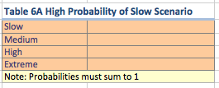choose probabilities for the SLR scenarios such that the “Slow” scenario has the highest probability of occurring and the extreme scenario the lowest.**

**In Table 6B choose probabilities for the SLR scenarios so that the “Extreme” scenario has the highest probability of occurring.**

As you enter the probabilities into Tables 6A and 6B, you will notice that Table 6C populates with the expected marginal damages, and the graph on the right displays the expected MD curves for each set of probabilities.

**Copy and paste the graph of Table 6C below.**

**Figure 6C: Expected MD from Flooding by 2100**

(Paste graph here)

**Pause for Analysis**

|  |
| --- |
| 4. Looking at the graph above and considering what you now know about calculating expected values, how do the probabilities affect the expected MD curves? |
|  |

The final step in our analysis is to consider how much it would cost to prevent these damages. One of the options to consider is building a sea wall along the shoreline that would prevent the water from reaching the homes given a flooding event.

In a report on cost estimates of coastal protection, the researchers estimate that the cost of building a sea wall is $762 per square foot (Hudson et al. 2015).

If Ruston Way is considered the highest priority shoreline, and it is 4.2 miles long, we can estimate that the cost of a 1-foot sea wall covering the entire distance would be $16.9 millions dollars. To simplify the analysis, we will assume that the cost of building the sea wall one foot taller is **constant** at $762 per square foot.

**Use this information to fill in the ‘Marginal Cost’ column in Table 7.**

**Make a graph that displays the Marginal Cost and Expected Marginal Damages given different flood levels. Make sure to give the graph a title and to label the x- and y-axes.**

**Copy and Paste your graph from Excel into the space below:**

**Pause for Analysis**

|  |
| --- |
| 5. Based on your graph above, what recommendation would you make to an urban planner regarding SLR adaptation in Tacoma? |
|  |
| 6. What is one assumption that is underlying the graph of Table 7 and if you were to change this assumption, how do you think the results change? |
|  |
| 7. What are some of the limitations of using these graphs for decision-making? |
|  |

**References**

DeConto, R. and Pollard, D. 2016. Contribution of Antarctica to past and future sea-level rise. *Nature*. 531, 591–597. doi:10.1038/nature17145

Hauer, M. E., J. M. Evans, and D R. Mishra (2016). Millions projected to be at risk from sea-level rise in the continental United States. Nature Climate Change.

Murphy, J. October 14, 2015. The Nation. Retrieved from: <https://www.thenation.com/article/3-years-after-hurricane-sandy-is-new-york-prepared-for-the-next-great-storm/>

Hudson, T., Keating, K., and Pettit, A. 2015.Cost estimation for coastal protection – summary of evidence. Environmental Agency. Report –SC080039/R7

National Geographic Magazine. Antarctica is Melting at a Dangerous Pace – Here’s Why. June 22, 2017. Retrieved from <http://video.nationalgeographic.com/video/magazine/170622-ngm-antarctica-melting-sea-levels-climate-change>

NOAA 2017: Sweet, W. V., Kopp, R. E., Weaver, C. P., Obeysekara, J., Horton, R. M., Thieler, E. R., and Zervas, C. (2017). Global and Regional Sea Level Rise Scenarios for the United States. NOAA Technical Report NOS CO-OPS 083.

Parris, A., P. Bromirski, V. Burkett, D. Cayan, M. Culver, J. Hall, R. Horton, K. Knuuti, R. Moss, J. Obeysekera, A. Sallenger, and J. Weiss (2012). Global Sea Level Rise Scenarios for the US National Climate Assessment. NOAA Tech Memo OAR CPO-1. 37 pp.

Sneed, A. 2017. How Is Worldwide Sea Level Rise Driven by Melting Arctic Ice? *Scientific American*. June 5, 2017. Retrieved from: https://www.scientificamerican.com/article/how-is-worldwide-sea-level-rise-driven-by-melting-arctic-ice/

1. Scientific American article: https://www.scientificamerican.com/article/how-is-worldwide-sea-level-rise-driven-by-melting-arctic-ice/
2. National Geographic video link: https://video.nationalgeographic.com/video/magazine/170622-ngm-antarctica-melting-sea-levels-climate-change
3. Riskfinder.org website: https://riskfinder.climatecentral.org/place/tacoma.wa.us?comparisonType=city-council-district&forecastType=NRC_High&level=4&unit=ft
4. ArcGIS US Median home prices for 2012: https://www.arcgis.com/home/webmap/viewer.html?layers=8abd47c2988d497a8f24ad89180980c8
5. https://riskfinder.climatecentral.org/place/tacoma.wa.us?comparisonType=neighborhood-council-district&forecastType=NOAA2017_inthi_p50&impact=Housing&impactGroup=Buildings&level=4&unit=ft